Staying Alive: the Interdependence of Organ Systems in Life-Sustaining Processes

In order to survive, most organisms need oxygen, food, & waste removal. These vital jobs in the body need the cooperation of 2 or more organ systems. This is called interdependence.

STEP 1: Create a Life-Sized Body Map of Life-Sustaining Organ Systems

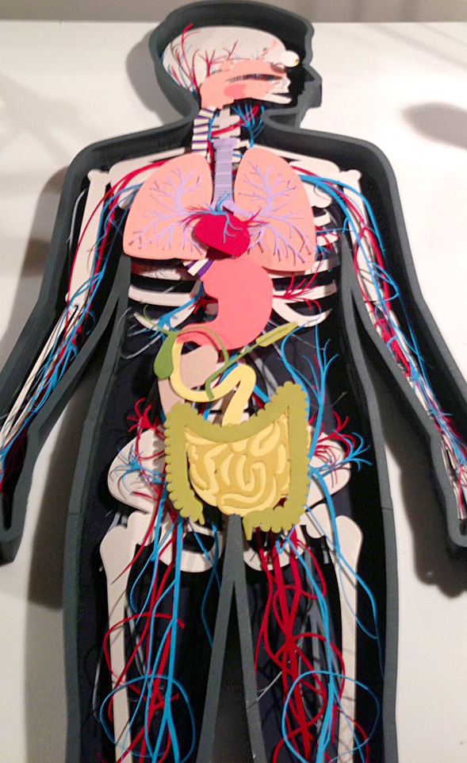
- Lay down on butcher paper in “anatomical position” (flat on back, palms facing up, head turned to the side). Ask a classmate to trace your outline onto the butcher paper using a pencil.

- Make needed adjustments to your outline so it actually looks like the outline of a human body, then trace the adjusted outline in black marker.

- Color/paint and label each organ. Remember to colour the veins as well as the right side of the heart blue & the arteries as well as the left side of the heart red. Make each organ a different colour.

- On the back of each organ, write its function. Consider typing, cutting, & pasting if your handwriting is messy.

- Tape organs to the right place on your butcher paper body so they can be lifted up to expose descriptions and organs underneath. Draw/paint veins & arteries.

STEP TWO: Write a Series of Information Paragraphs

- Describe the interdependence of 2 or more organ systems in key life-sustaining processes. Use the attached paragraph templates to organize & publish typed paragraphs.
- Describe how the respiratory & circulatory systems work together to obtain and transport oxygen, with special emphasis on the role of the alveoli.
- Describe how the digestive & circulatory systems work together to obtain & transport nutrients to cells, tissues, and organs; with special emphasis on the role of the villi.
- Describe how the respiratory, circulatory, digestive, & excretory systems work together in the process of waste removal; including the role of the lungs, kidneys, liver, sweat glands, & large intestines.

- Tape these paragraphs to the right place on your butcher paper body’s organs or glue them to a border around your butcher paper body with arrows pointing to the key organ involved in the process.
Gas Exchange

The respiratory and circulatory systems work together in the process of gas exchange to obtain & transport oxygen to cells, tissues, and organs. First, <describe the process of inspiration and the path oxygen takes from the mouth or nose through various organs to the alveoli of the lungs>. Next, <describe how gas exchange takes place in the capillaries around the alveoli>. Then, <describe how red blood cells transport oxygen & carbon dioxide to and from cells, tissues, and organs in the body through the heart>. Gas exchange is important to humans because <describe why humans would die without gas exchange>.

Absorption

The digestive and circulatory systems work together in the process of absorption & transportation of glucose. First, <describe how food is ingested and the path it takes through various organs as it’s broken down into particles small enough to enter the small intestine>. Next, <describe how nutrients enter the blood stream through capillaries in the villi>. Last, <describe how nutrients are transported by plasma to the liver>. Absorption is important to humans because <describe why humans would die without absorption>.

Waste Removal

The respiratory, digestive, urinary, integumentary, & circulatory systems work together in the process of waste removal. Waste gas is removed by the respiratory & circulatory systems. <Explain the process of expiration and the path carbon dioxide takes from the alveoli through various organs to the nose or mouth>. Solid waste leaves through the digestive & circulatory systems. <Describe how stool is formed in the large intestines as well as how the liver & kidneys filter toxins from the blood>. Liquid wastes leave through the integumentary, urinary & circulatory systems. <Describe how water, urea, & electrolytes leave though perspiration & the urinary systems>. It is important that wastes not remain in the body because <describe why humans would die without waste removal>.

